Question 5

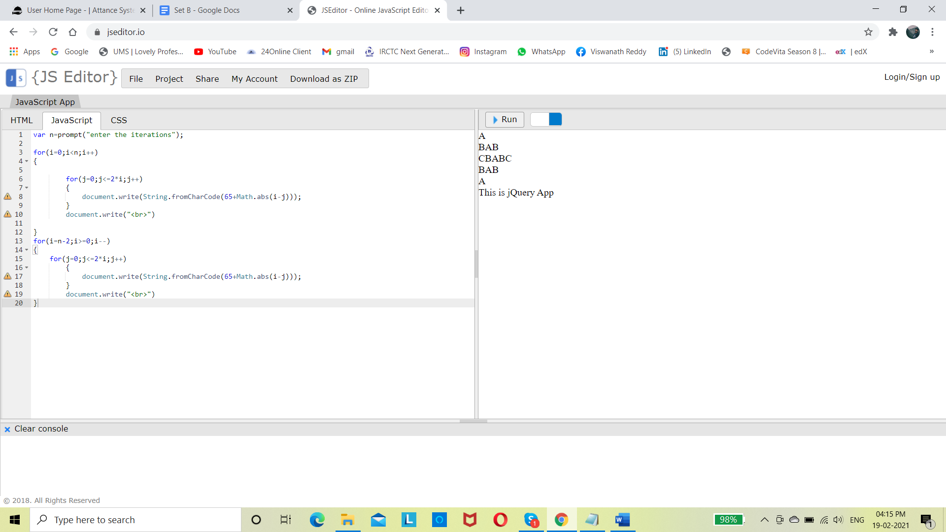

var n=prompt("enter the iterations");

for(i=0;i<n;i++)

{

for(j=0;j<=2\*i;j++)

{

document.write(String.fromCharCode(65+Math.abs(i-j)));

}

document.write("<br>")

}

for(i=n-2;i>=0;i--)

{

for(j=0;j<=2\*i;j++)

{

document.write(String.fromCharCode(65+Math.abs(i-j)));

}

document.write("<br>")

}

Question 1

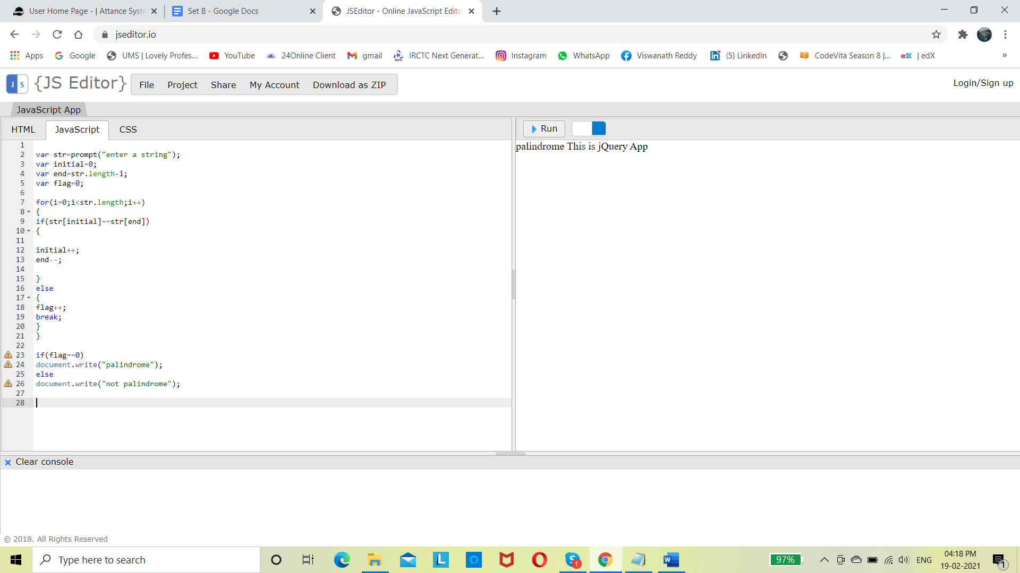

var str=prompt("enter a string");

var initial=0;

var end=str.length-1;

var flag=0;

for(i=0;i<str.length;i++)

{

if(str[initial]==str[end])

{

initial++;

end--;

}

else

{

flag++;

break;

}

}

if(flag==0)

document.write("palindrome");

else

document.write("not palindrome");

question 2

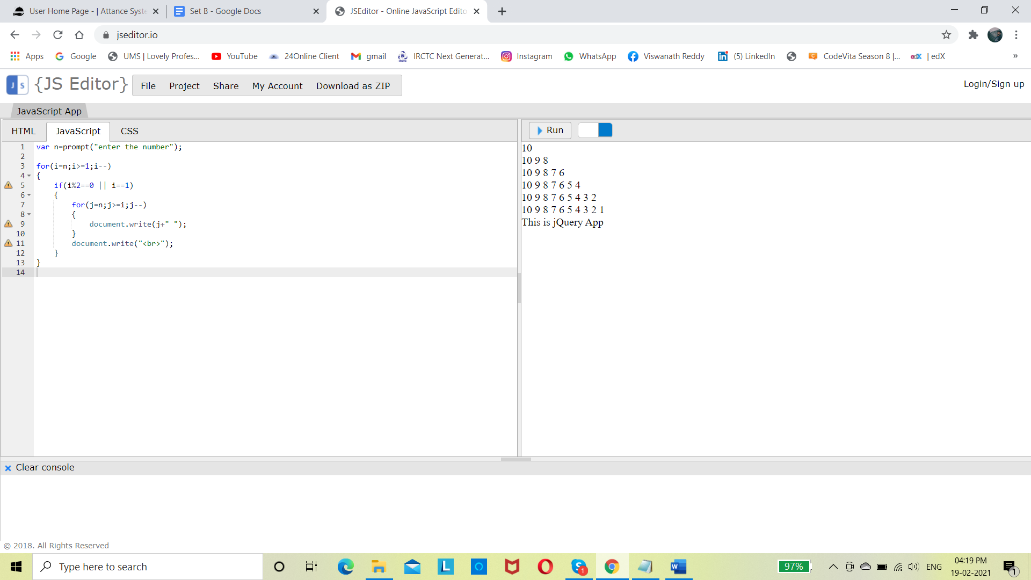

var n=prompt("enter the number");

for(i=n;i>=1;i--)

{

if(i%2==0 || i==1)

{

for(j=n;j>=i;j--)

{

document.write(j+" ");

}

document.write("<br>");

}

}

Question 3

var n= parseInt(prompt("enter the number"));

for(i=0;i<2\*n;i++)

{

for(j=1;j<=2\*n;j++)

{

if(i<n)

{

if(j<=n-i||j>n+i)

{

document.write("\*");

}

else

{

document.write("&nbsp&nbsp");

}

}

else

{

if(j<=i-n+1||j>=((n\*2)-(i-n)))

{

document.write("\*");

}

else

{

document.write("&nbsp&nbsp");

}

}

}

document.write("<br>");

}

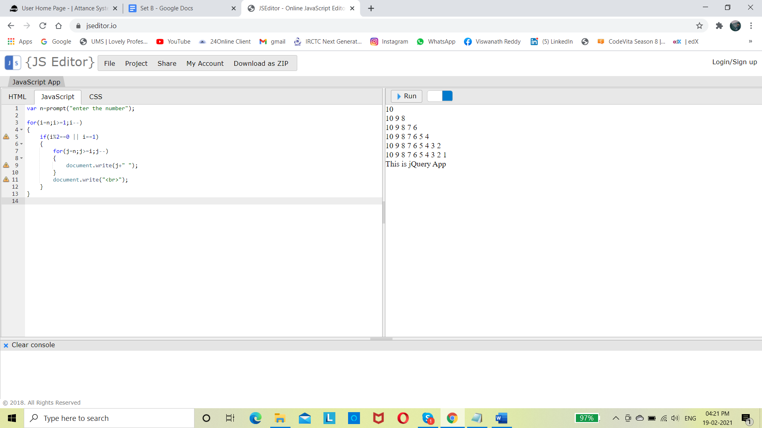

Question 4

question 4

var n=prompt('no of lines you want to run');

for(var i=1;i<=(n\*2)-1;i++)

{

if(i<=n)

{

for(var j=1;j<n-i+1;j++)

{

document.write('&nbsp&nbsp&nbsp');}

for(j=1;j<2\*i;j++)

{

document.write('&')

}

document.write('<br>')

}

else

{

var c =0;

for(var j=i-n+2;j>2;j--)

{

document.write('&nbsp&nbsp&nbsp');

c++;

}

for(j=1;j<(2\*n)-(c\*2);j++)

{

document.write('&')

}

document.write('<br>')

}

}

